**Angel Girl**

The Full Moon cries with me

I am waiting for a lover who shares her contingency

my Venus in Pisces

has left me here longingly

I’m too fragile to be a star

perpetually in the state of falling

somewhere above me they wrote my story

but left me no part in personal belongings

Could I live forever in a daydream

You here in the passenge seat?

The drones and cicadas

A pause before the beating

**The Fae have no souls**

I stared at the corners of your eyes

**softening**

as if you had been or were just about to be

**weeping**

The wild horse laid exhausted and

**sleeping**

I killed a deer and no one stopped

**me**

Put on angel wings and pretended I had

**died**

Meet me after the after party

You can tell me all about the

**wildfires**

Tell me who do you pray too

***And does her dissonance sound like this?***

**I can walk on water if I run fast enough**

I built the cosmos on my bedroom ceiling

expanding make-believe constellations on the plaster

creating patterns to be better understood later

contemplating an explosion of life beyond the moon

as we lay on the bed ridding ourselves

of the old ways of money

by selling our bodies as they are

holy

our curves moody and mirroring

galaxies a billion years ago and still

living

At night

I hold counsel with the northern stars

collecting zodiacs and birthing my mythologies

a world of infinite mania

run by Goblin Kings and Aphrodites

No place can claim me

No person can claim me

I am beyond belief

I am **divinity**

**This Video is Being Surveilled**

If you catch me collecting feathers on the street

and burning my hair at the altar

**Don’t take me**

If you see me walking away from the shore

with years collections of lonely stones in my pocket

**Don’t take me**

If you hear me question your presence

Considering the voices in the radio static

and decoding messages in the TVs subtitles

**Don’t take me**

**Don’t take me away**

during this summer’s heat

Let the streets breathe

Let me write again in the darkness where I place my thoughts at rest

Where I can hang my tongue in the back of my throat

and reserve my lips for honey

Sending out a signal through my telepathy phone

Hey pick up

Hey can you hear me?

Why did you always speak so quietly

So softly like a little bitch

Learn to open your mouth so wide

even the deaf can hear

I’m sorry I said that overstepping boundaries

**I am sorry I say anything**

**don’t take me don’t take me don’t take me don’t take me**

The sunsets are half as pretty from inside thick windows

I swear I remember it all like it was yesterday

Chocolate milk cartons and karaoke midday

**don’t take me don’t take me don’t take me**

**please**

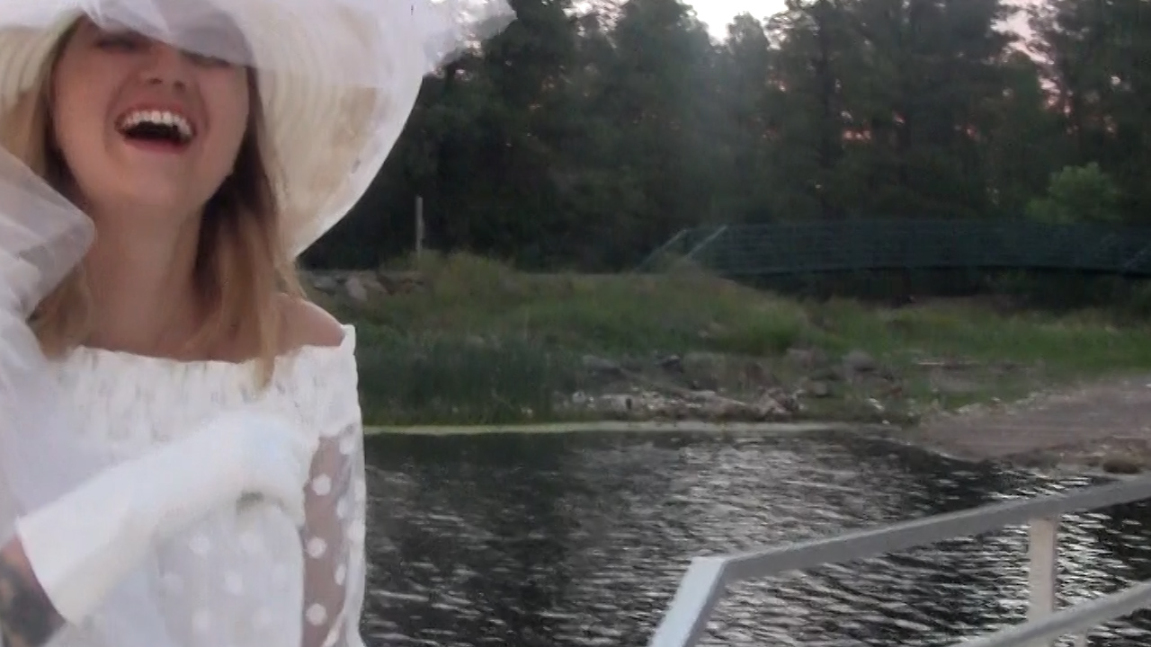

I Love You,

BAEVY

Video Available at

www.baevy.love

@bae.vy